Project B: A series of interesting 3D shapes rendered using ray-tracing techniques.

Michael Huyler – msh1851

# User guide

## Navigation

The user can fully navigate the 3D scene in front of them using a combination of keypresses and mouse drags. Pressing the W and S keys move the camera forwards and backwards respectively, while the A and D keys strafe to the left and right. Clicking and dragging the mouse rotates the camera accordingly.

## Utility

While all ray-tracing related actions can be performed using the GUI in the top-right corner of the screen, many actions can also be quickly performed using the keyboard as well. These are:

* T – render the image to match the WebGL preview.
* Up/Down Arrow Keys – increase/decrease the image resolution.
* Right/Left Arrow Keys – increase/decrease the recursive depth of reflections.
* PgUp/PgDn – increase/decrease the number of supersamples for antialiasing.
* J – toggle jittering.
* 1/2/3/4 – select a template scene (1-4) to preview.
* 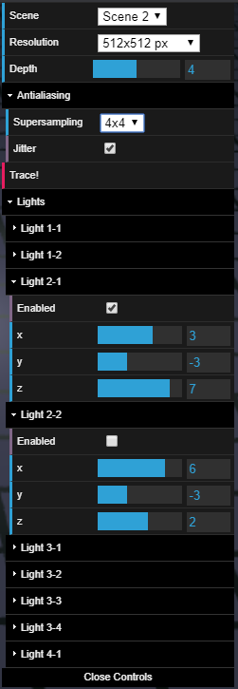. [Period] – toggle the help menu.
* / [Forward Slash] – toggle the GUI menu.

The lights in each scene are also manipulatable, however this must be done through the GUI. Their settings are located in the Lights subfolder. Each light has its own subfolder within the Lights subfolder, labeled using the convention “Light [Scene #]-[Light #]” to ensure uniqueness. Expanding an individual light’s folder, the user can enable/disable the light, as well as reposition it by utilizing the sliders for each coordinate.

Figure 0 (right): The expanded GUI menu with several setting changed.

# Results

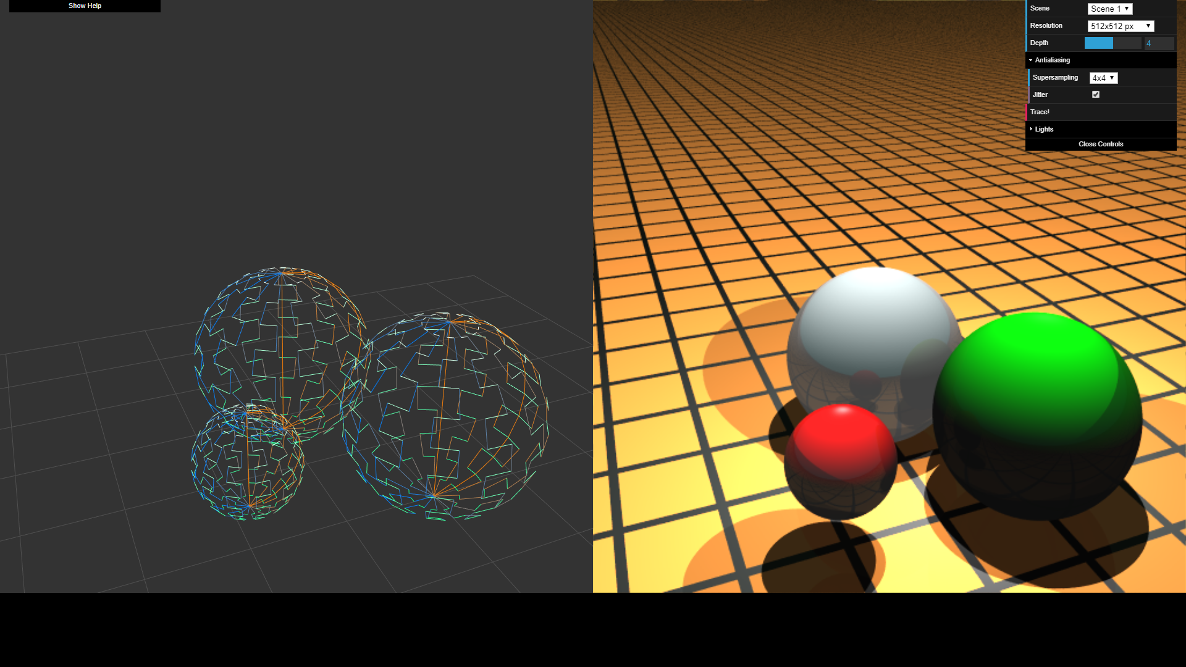

Figure 1: The first template scene. Three spheres of varying materials and sizes, with visible reflections.

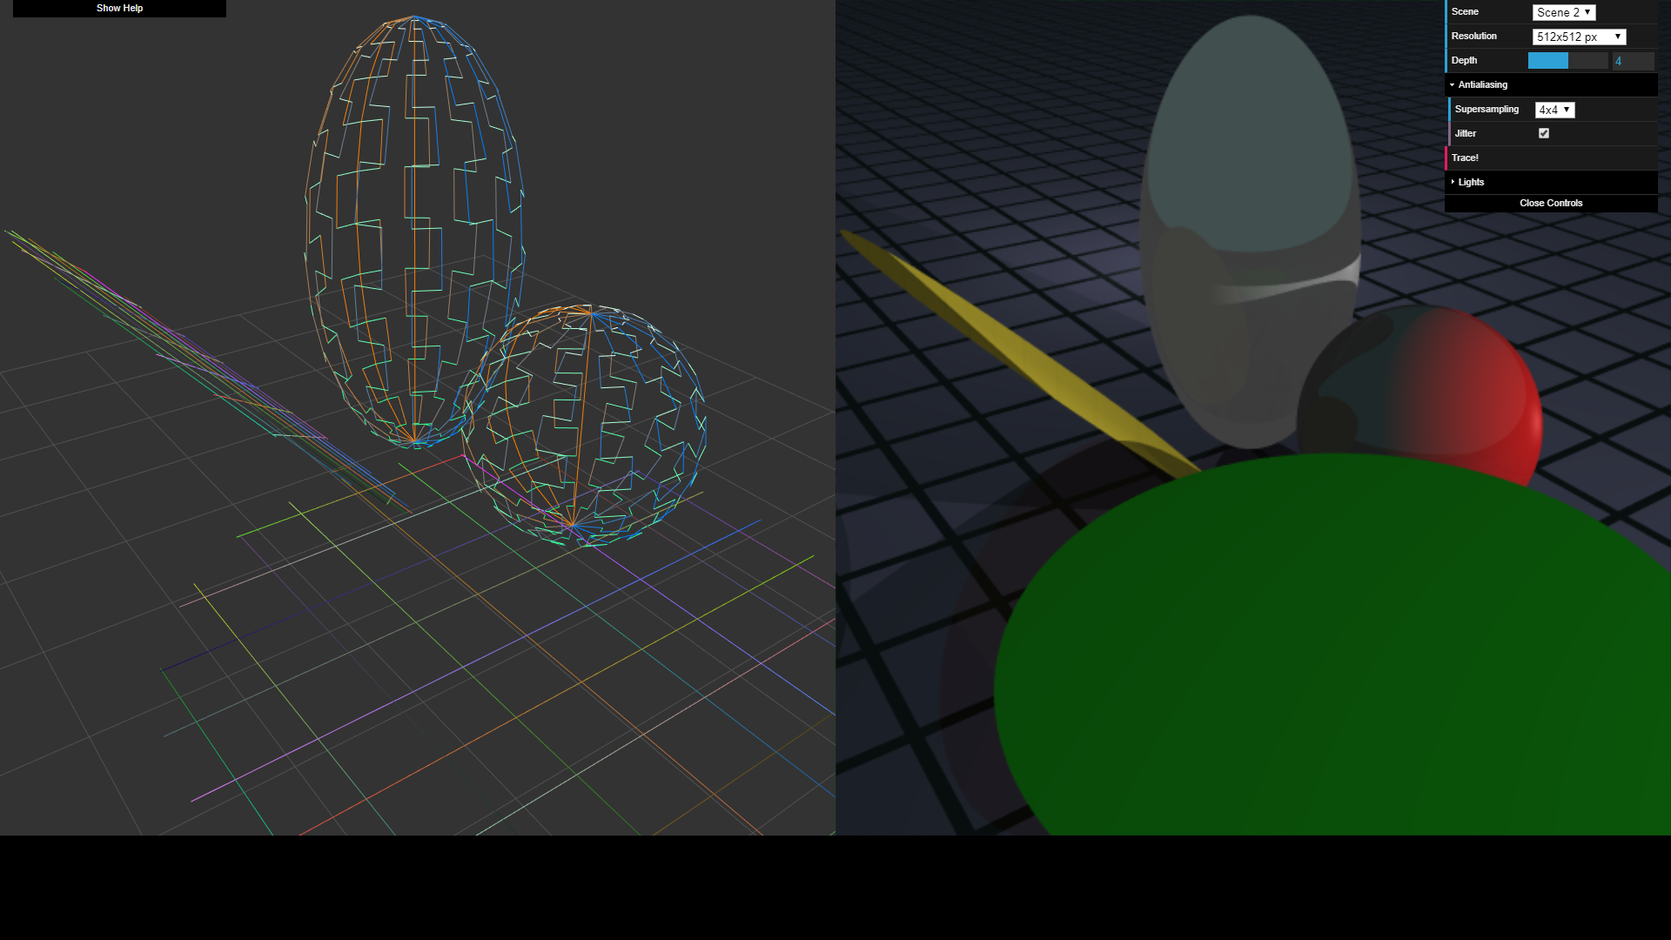

Figure 2: The second template scene. Two spheres (top and right) and two discs (bottom and left).

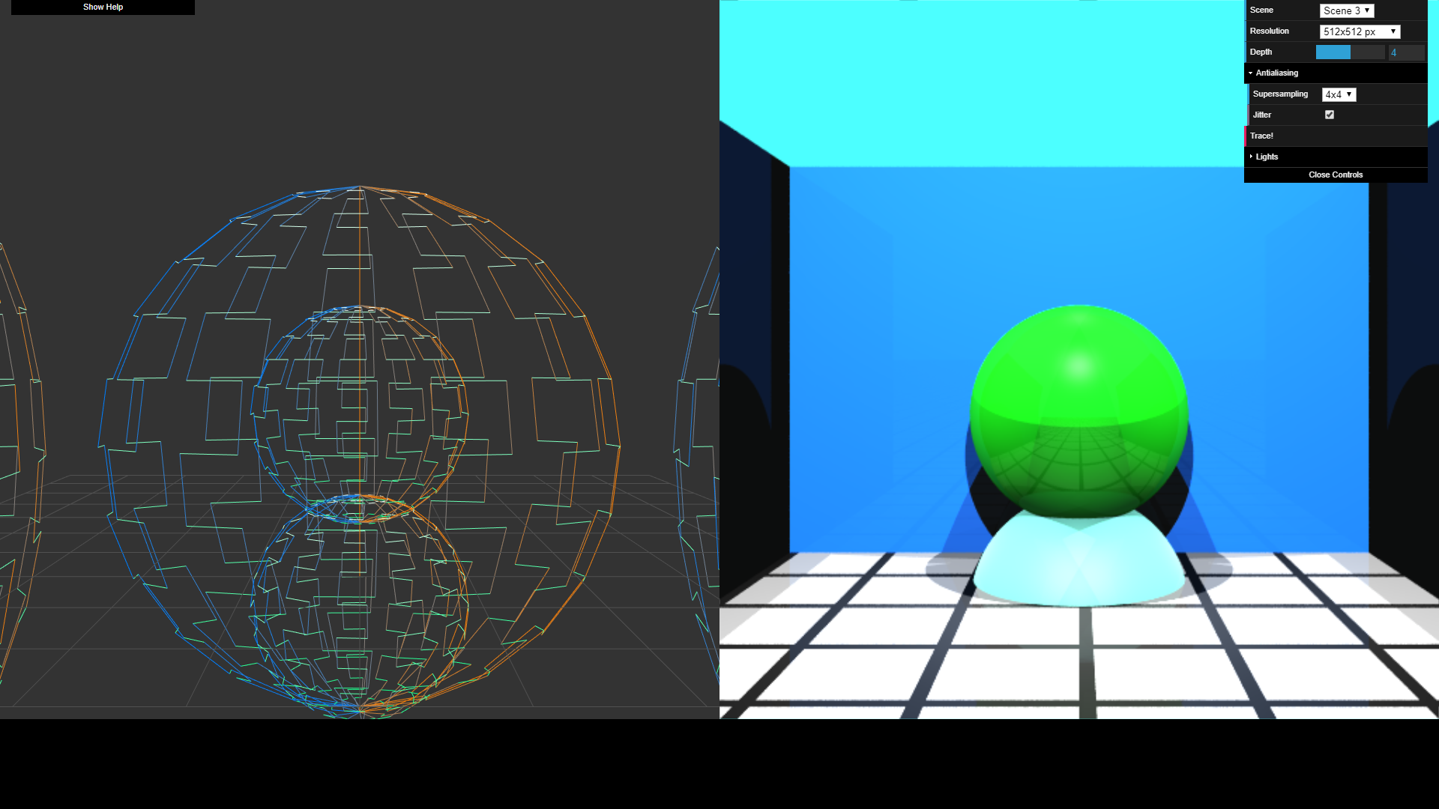

Figure 3: The third template scene. Two spheres (center) and 3 ray-marched cubes which form an enclosure.

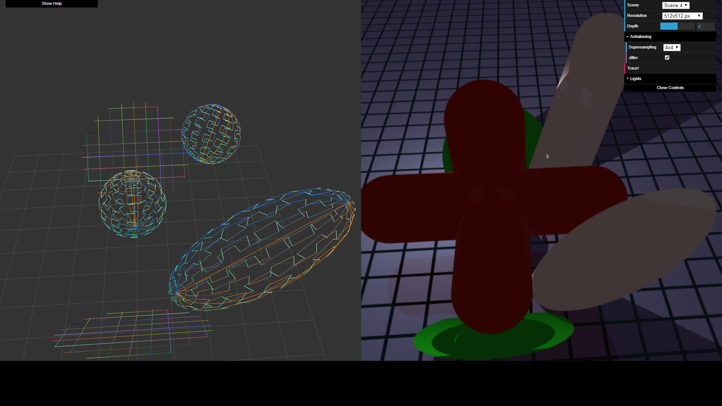

Figure 4: A stretched sphere (bottom right), two discs (top and bottom), an implicitly ray-marched capped cylinder (top right), and a CSG union of several capped cylinders (center).

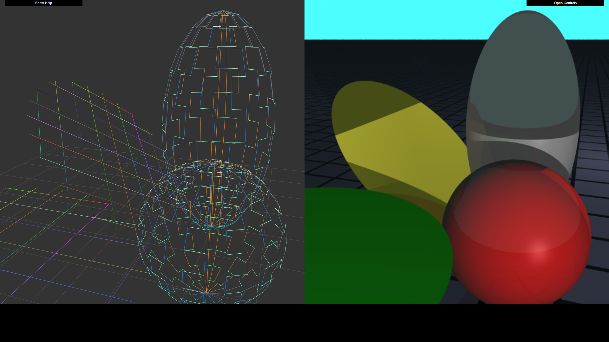

Figure 5: Scene 2 viewed from an alternate angle.

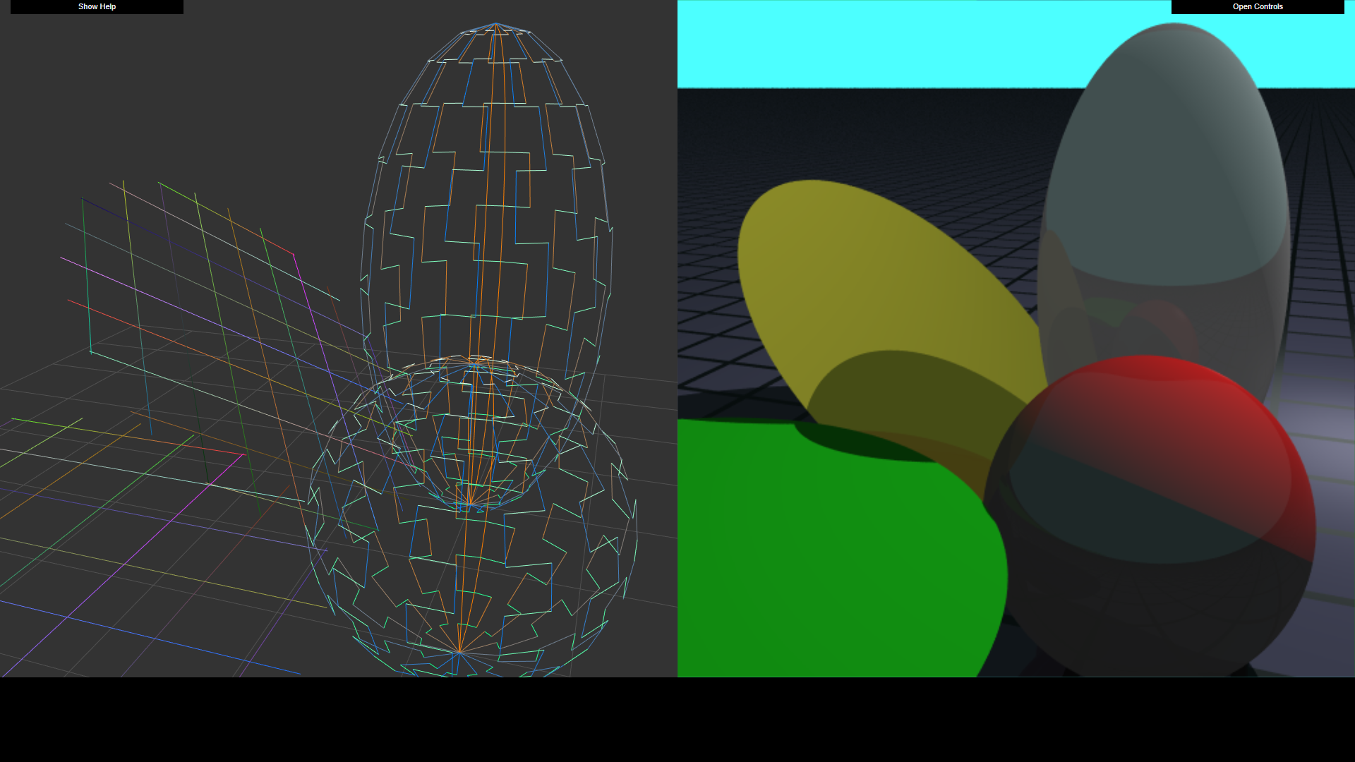

Figure 6: Modified from figure 5 with a different light positioning.